
SOP: Scan, Validate, & Print

Printing tags 2
Troubleshooting 6
Revisions 8


SOP: Scan , Validate, & Print
Audience
- Location manager
- Location employee
Supplies
- Handheld device
- Login details
Purpose: Use this guide to print RFID tags for products.
If you do not have a handheld device login, ask your location manager to set one up for you.

Printing tags
Step | Action | Image
1 | On the TC Device, tap the square icon next to the ⚙ symbol.  Verify Bluetooth is enabled (icon is blue).  Exit the menu. | 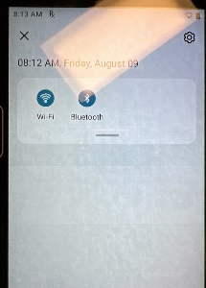  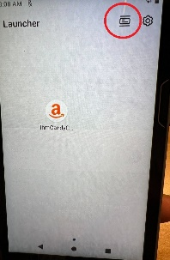
2 | Open the IhmCandyCane app. | 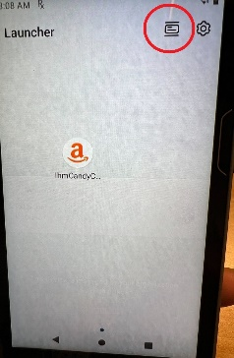
3 | On the printer, locate the Bluetooth MAC Address by selecting Printer Info. | 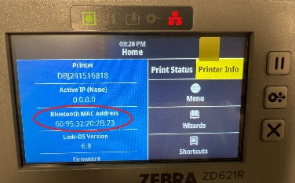
4 | Tap the menu in the top left corner of the screen to open the Store Tools dropdown.  Then, select Scan, Validate, & Print. | 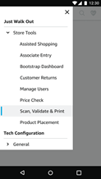
5 | Enter the Mac Address of the printer into the form field.  Note: When entering the Mac Address use the colon ‘:’ as indicated on the printer display. | 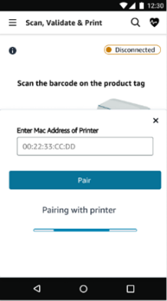
6 | Then, select Pair. | 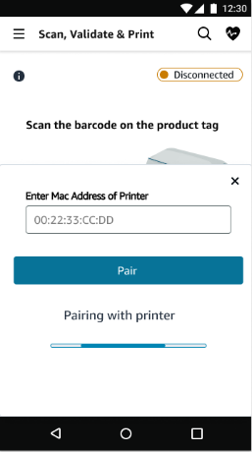
7 | If the pairing is successful, a 'Pairing complete' message will appear.  To begin scanning, select the 'x' in the upper left corner of the Pairing complete message box. | 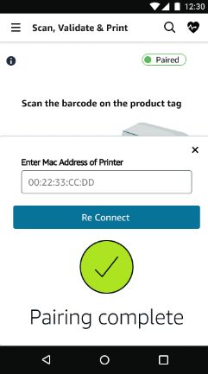
 | If the pairing is unsuccessful, a 'Pairing Unsuccessful' message will appear.  Ensure that the printer is powered on and that Bluetooth is enabled on the handheld device, then try to pair again.  If pairing attempts continue to be unsuccessful, contact Just Walk Out technology Support for assistance. |   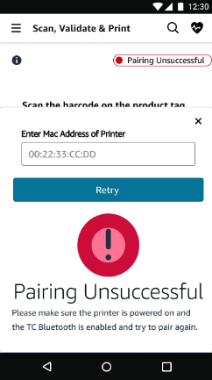
8 | Scan or manually enter the product barcode by pressing the button on either side of the handheld device.  Adjust the quantity of tags to be printed by entering in the amount into the quantity field or by selecting the '+' or '-' buttons. | 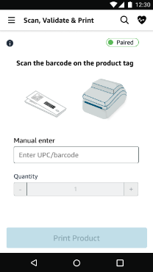    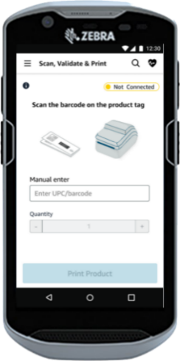
9 | Verify that the product displayed matches the one scanned or manually entered by checking the on-screen product images and confirming the tag quantity to print.  When confirmed, select 'Print'. | 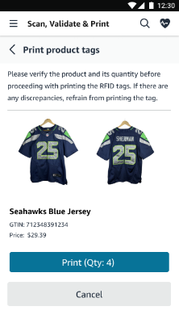
 | The Not Printable screen indicates that the product is not ready for RFID tag creation and application due to one or both of the following reasons:
 | Partial Success.  Image Validation: This product does not have images on file. Click ">" and then select "Upload/re-upload image" to begin the image capture process. | 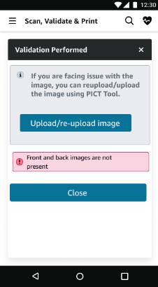  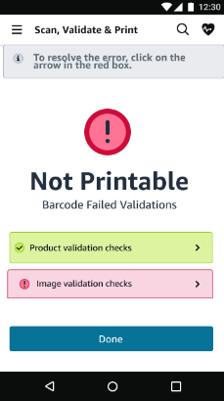
 | Product Validation: This product is not included in the Amazon catalog, or there is missing product information in the catalog entry.  To correct this, the Location Manager must log into the Merchant Portal and update the details before an RFID tag can be printed. | 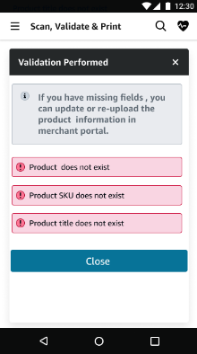
10 | Collect all printed tags from the printer.  If any tags are missing or contain errors, reprint the necessary tags. | 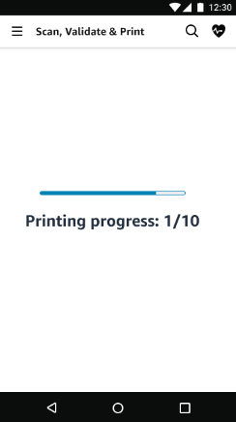  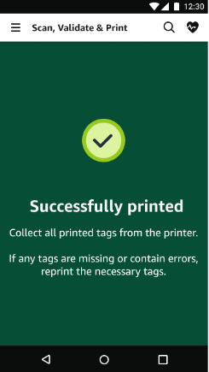
11 | After successfully printing the tags, you will be redirected to the product scanning screen.  You can then begin scanning or entering your next product to continue. | 


Troubleshooting
Error | Image
Unsuccessful scan  Try scanning the barcode again. If the error persists, check the product tag for another barcode to scan.  If another barcode cannot be found or continues to lead to this screen, contact your Location Manager. | 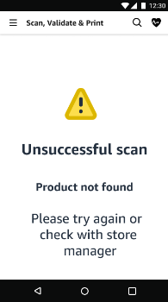
Bluetooth is not enabled on the Handheld Device    Tap the Recent Apps icon in the upper right-hand corner of the device.    Confirm the Bluetooth icon is blue.    Press the Recent Apps icon to return to the pairing process. | 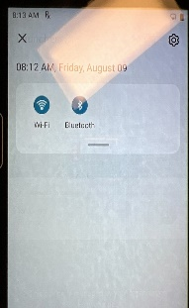  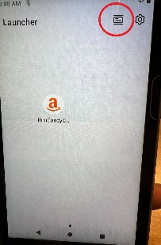
Barcode is unreadable  Try scanning the product barcode once more. If the error persists, contact your Location Manager. | 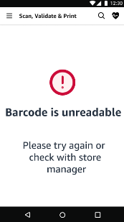
Error Fetching EPC’s  Select “Retry Fetching EPC.”  If the error persists; contact your Location Manager. | 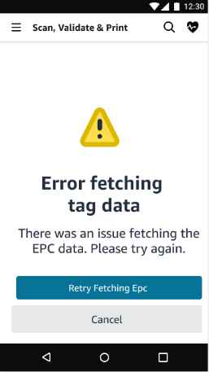
If errors cannot be solved by following the troubleshooting steps above, please reach out to Just Walk Out technology support by calling or emailing.
1-855-218-4421 - jwosupport@amazon.com


Revisions

Date | Version | Revision Notes | Author
08/2024 | 1.0 | Creation | rachshan
08/2024 | 1.1 | V1 Edits | rachshan
1/2025 | 1.2 | Updated pairing steps | rachshan

